Birla Institute of Technology & Science, Pilani
Work-Integrated Learning Programmes Division
Second Semester 2019-2020

Mid-Semester Test
(EC-2 Regular)

Course No. : SS ZG514
Course Title : OBJECT ORIENTED ANALYSIS & DESIGN
Nature of Exam : Closed Book
No. of Pages = 2

No. of Questions = 6
Weightage : 30%
Duration : 2 Hours
Date of Exam : Sunday, 08/03/2020 (FN)
Note:
- Please follow all the Instructions to Candidates given on the cover page of the answer book.
- All parts of a question should be answered consecutively. Each answer should start from a fresh page.
- Assumptions made if any, should be stated clearly at the beginning of your answer.

- Sketch the diagram given below and label items (b) to (k) as per the text description of Unified Process. [0.5 x 10 = 5]
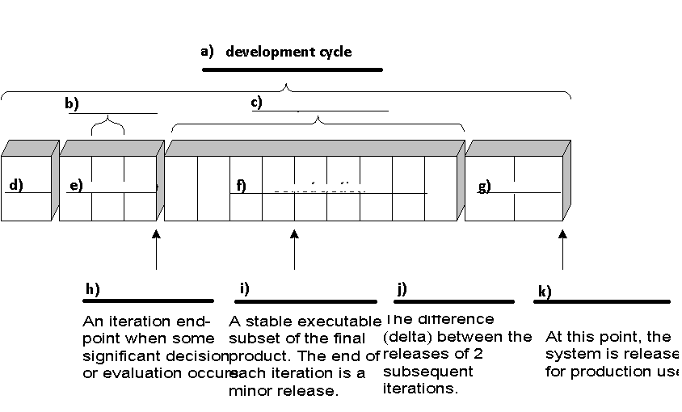

- Although iterations include work in most disciplines the relative effort and emphasis change over time. Named any 5 UP disciplines studied in the text and draw a sketch to demonstrate the relative effort over various phases for each. [1 x 5 = 5]

- Explain the role of processes, tools, documentation, contracts and predictive planning in the context of Agile Processes. Explain with an example using the Scrum Approach to Project Execution. [5]
SS ZG514 (EC-2 Regular) Second Semester 2019-2020 Page 2

- Name 4 artifacts that have been taken up in this course for recording requirements for an application. Sketch each and explain how they corelate with one another. [5]

- The use case text for UC: Process Sale has been reproduced below from your textbook:
1. User selects new sale option
2. System requests item identifier
3. User enters item identifier
4. System records sale of item, and
5. System displays item description, price, current total
Steps 2-5 repeated until user finished
6. User selects sale finished option
7. System displays total and taxes due
8. User selects payment option
9. System requests payment information
10. User enters payment information
11. System handles payment
12. System logs completed sale and sends sale information to Accounting System and Inventory System
13. System generates receipt
Sketch the SSD for the above UC. [5]

- Please study the diagram given below and draw a Sequence Diagram to describe the same process.
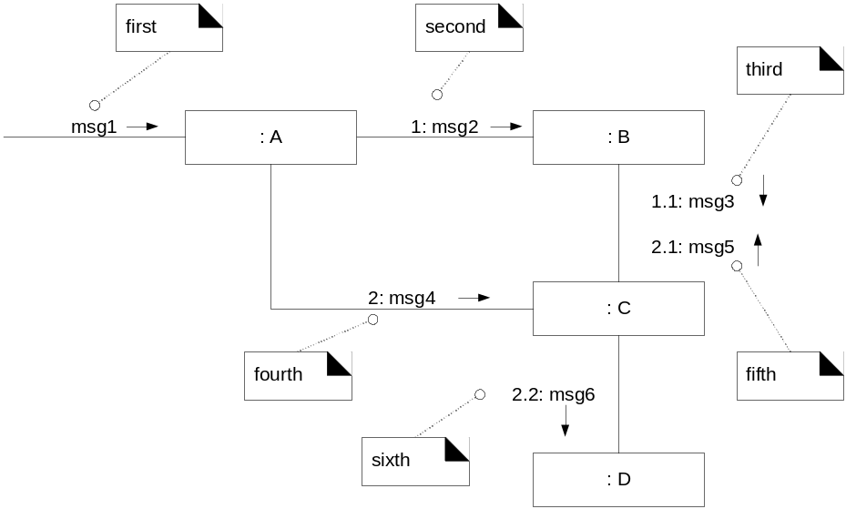 [5]

